# Abstract

Reading has always instilled ideas in the heads of creative people and developed into new inventions, from the "Earth" program in Neil Stephenson's novel "The Avalanche", from which the "Google Earth" application was inspired.

Of course, the importance of reading is not the subject of the document. We all understand the importance of reading, and our project is very important for everyone who reads because it will simply change the concept of regular reading and will help extract important information in more than one form and will help to understand the texts better and thus get many inspirational ideas .

We provide three services through our App:

1-Automatically generating Word cloud a word cloud is a collection, or cluster, of words depicted in different sizes. The bigger and bolder the word appears, the more often it’s mentioned within a given text and the more important it is.

2-Automatically generating summary is a shortened version of a text.

Given long documents to read, our natural preference is to not read, or at least, to scan just the main points. So having a summary would always be great to save us time ⏳ and brain processing power.

3-Automatically generating mind maps out of pure text and that requires many stages of text processing

In addition, in order to be able to achieve all of this we are focusing on Natural Language Processing or NLP for short, is broadly defined as the automatic manipulation of natural language, like speech and text by software and of course, we will using python.

# 1- Introduction

When a Falcon rocket blasted into space in February 2018, it was carrying an unexpected payload. Unlike the red "Tesla Roadstar" car and the doll in the astronaut suit behind the steering wheel, SpaceX founder Elon Musk put in the front glove box of the car the "foundation" series of novels by Isaac Asimov recorded on an optical disk. Its events took place in a future era after nearly 50,000 years, igniting his passion for space travel as a teenager. It has now been flying in space around our solar system for about 10 million years or more.

Reading has always instilled ideas in the heads of creative people and developed into new inventions, from the "Earth" program in Neil Stephenson's novel "The Avalanche", from which the "Google Earth" application was inspired, to phones that have the ability to sense in Arthur C. Clarks' novel, which She led Tim Berners-Lee to invent the World Wide Web. Barack Obama says that reading helped him get to know himself and shaped his beliefs.

I have mentioned all these examples to demonstrate the importance of reading and that it was the first inspiration for all the great people who changed the course of history.

The question now is what is the relationship of all this to our project?

Our project aims to launch many services that facilitate the task of reading, and we can mention, for example, the word cloud, and the summary of texts. All these services will help attract many readers and help them to reach the purpose of every article, report or scientific content that they read easily and without effort, our project will help many creative people to continue achievements, change the concept of reading for some, and continue working until reading becomes an enjoyable activity.

# 2- Domain model

***What is mind map?***

Mind mapping is a popular brainstorming tool and thinking technique of visually arranging ideas and their interconnections. It is a way of representing related thoughts with symbols rather than with inessential words. The human mind forms associations almost promptly, and "mapping" allows capturing these ideas quicker than expressing them using only words or phrases. Originated in the late 1960s by Tony Buzan (1). It is now used by millions of people around the world.

Manually creating mind maps requires comprehensive reading and good understanding the text which takes much time and effort. In addition to that not all people are inventive enough to draw elegant and meaningful mind maps.

Therefore, automatically generating mind maps spares much time and exertion and serves way better and speedier several applications .

The applications that make the mind map is Xmind , FreeMind, Edraw MindMap, and MindMeister.

But this applications are manual, because the user manually determines the mind map element These softwares help the user in drawing the mind map and have some ready designs and diagrams which can be used. But the user must read, understand the text well and come up with a design for the mind map himself.

We provide Automatically generating mind maps out of pure text and that requires many stages of text processing.

***What Is Word Cloud?***

Word clouds (also known as text clouds or tag clouds) work in a simple way: the more a specific word appears in a source of textual data (such as a speech, blog post, or database), the bigger and bolder it appears in the word cloud.

A word cloud is a collection, or cluster, of words depicted in different sizes. The bigger and bolder the word appears, the more often it’s mentioned within a given text and the more important it is.

Also known as tag clouds or text clouds, these are ideal ways to pull out the most pertinent parts of textual data, from blog posts to databases. They can also help business users compare and contrast two different pieces of text to find the wording similarities between the two.

Perhaps you’re already leveraging advanced data visualization techniques to turn your important analytics into charts, graphs, and infographics. This is an excellent first step, as our brains prefer visual information over any other format.

Yet, what do you do if your raw data is text-based in nature?

Much of the research your organization conducts will include at least some form of an open-ended inquiry that prompts respondents to give a textual answer.

For instance, you might ask current customers what they like or don’t like about your new product line. Or, you could ask them to give suggestions on how your organization could improve. They could also have the chance to elaborate on any pain points they’re experiencing.

There are industry tools that allow you to code such open-ended data so users can understand it quantitatively. Yet, these don’t come cheap. Word clouds offer a cost-effective, yet powerful, alternative.

With these, you can still quantify your text-based insights into measurable analytics. The only difference? You won’t create a chart or graph as you would with a set of numbers.

Instead, you’ll create a word cloud generator to transform the most critical information into a word cloud.

Here’s an example from USA Today using U.S. President Barack Obama’s State of the Union Speech 2012

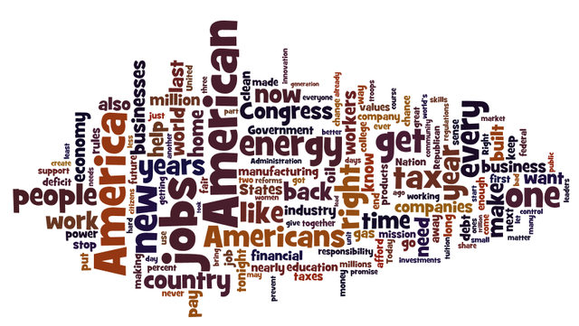

**Advice for CHOOSING Word cloud (tips and traps)**

Take time to clean up the data before importing it into the word cloud generator. For example, interview transcripts, may have common conversational fillers such as “you know” or “like” that need to be removed.

Ensure that the data collection team documents key words consistently– with consistent capitalization – since some software packages will not recognize capitalized and uncapitalized words as the same.

***So, What about Summarization?***

The navigation through long documents in order to find the interesting information is a tough job and waste of the time and effort. Automatic text summarization is a technique concerning the creation of a compressed form for single document for tackling such problem. we introduced a solution for automatic text summarization problem; we tried to exploit different resources advantages in building of our app like advantage of diversity based method which can filter the similar sentences and select the most diverse ones and advantage of the non diversity method .

Moved by the cutting edge advancement and Innovation, Data is to this century what oil was to the last one. Today, our reality is parachuted by the gathering and dissemination of huge amounts of data.

In fact, the International Data Corporation that the total amount of digital data circulating annually around the world would sprout from 4.4 zettabytes in 2013 to hit 180 zettabytes in 2025. That’s a lot of data!

With such a huge amount of data circulating in the digital space, there is a need to develop algorithms that can automatically shorten large huge texts and summaries that information that can fluently pass the intended messages.

However, auto-summarization used to be an impossible task. Specifically, abstractive summarization is very challenging. Differing from extractive summarization (which extracts important sentences from a document and combines them to form a “summary”), abstractive summarization involves paraphrasing words and hence, is more difficult but can potentially give a more coherent and polished summary.

Approaches

The summary should retain the most important points of the original text document. A good text summarizer should also take into account variables such as length, writing style and syntax of the original document.

Current approaches to automatic summarization fall into two broad categories: extraction and abstraction. Extractive methods work by selecting a subset of existing words, phrases, or sentences in the original text to form the summary. In contrast, abstractive methods first build an internal semantic representation and then use natural language generation techniques to create a summary. Such a summary might contain words not explicitly present in the original document.

Key challenges in text summarization include topic identification, interpretation, summary generation, and evaluation of the generated summary. Most practical text summarization systems are based on some form of extractive summarization. Abstraction based summarization is inherently more difficult and is an active area of research.

All extraction based summarizers, irrespective of the differences in approaches, perform the following three relatively independent tasks:

(a) capturing key aspects of text and storing it using an intermediate representation.

(b) scoring sentences in the text based on that representation.

(c) and composing a summary by selecting several sentences.

Abstractive Summarization

task in Natural Language Processing (NLP) that aims to generate a concise summary of a source text. Unlike extractive summarization, abstractive summarization does not simply copy important phrases from the source text but also potentially come up with new phrases that are relevant, which can be seen as paraphrasing. Abstractive summarization yields a number of applications in different domains, from books and literature, to science and R&D, to financial research and legal documents analysis.

To date, the most recent and effective approach toward abstractive summarization is using transformer models fine-tuned specifically on a summarization dataset. we demonstrate how you can easily summarize a text using a powerful model within a few simple steps.

On a high level, PEGASUS uses an encoder-decoder model for sequence-to-sequence learning. In such a model, the encoder will first take into consideration the context of the whole input text and encode the input text into something called context vector, which is basically a numerical representation of the input text. This numerical representation will then be fed to the decoder whose job is decode the context vector to produce the summary.

## 2.1 Related Work

### 2.1.1 M2Gen In 2009 (2)

The concept of M2Gen is to generate the Mind Map object from semantic model taken from a given text. The English text is transformed into a semantic model or meaning representation using numerous natural language understanding tools such as morphological analysis, parsing and Semantic Analyzer.

The complete procedure is shown in Figure 1.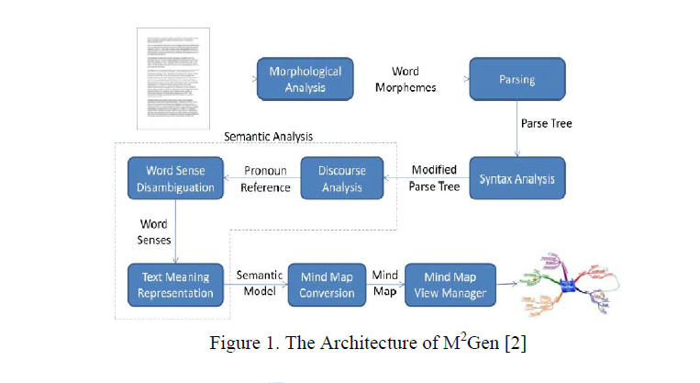

First, the English text is processed by morphological analysis in order to analyze each word into its lemma and affix along with its POS tag. The result of morphological analysis is then processed by parsing component by using CFG and top down chart parsing. Since not all parts of parse tree are used, then there is a parse tree alteration process in the syntax analysis. The result is then used by semantic analysis to produce the semantic model. The semantic analysis contains of several sub components such as discourse analysis, word sense disambiguation and text meaning representation. The discourse analysis aims to solve the pronoun reference in sentences .

The word sense disambiguation aims to select the best sense of a single word, and the text meaning representation aims to transform the parse tree result into the semantic model. The resulted semantic model is then converted into Mind Map figure. The example of generated Mind Map figure is shown in Figure 2.

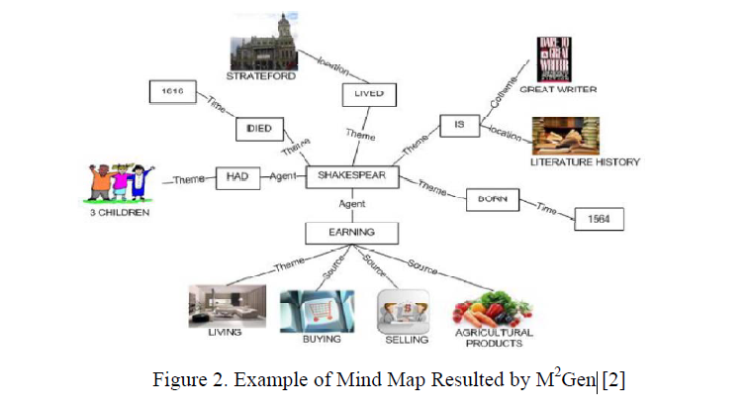

On the other hand:

* this version only supports single layer mind map and does not produce a hierarchical (multilevel)
* the images assigned to the nodes are not accurately representing them

### 2.1.2 Generating Mind Map from Indonesian Text using Natural Language Processing (3)

This make the process easier by generating mind map from text (here is Indonesian text) and providing mind map editor to manipulate the object and relation set.

To build such tool, they utilize obtainable Indonesian NLP (Natural Language Processing) tools.

There are three constituents needed: semantic net generator, mind map visualization and interaction handler. In the semantic net generator, the resulted first order logic (FOL) resulted by the semantic analyzer is changed into semantic net which is represented by roll of objects and roll of relations. The resulted semantic net is then imagined by using combination method of radial and layering drawing. The interaction is obtainable for editing the object and the relation. The tool was then assessed by 2-experiment set: testing the semantic net generation and testing the resulted imagining.

The semantic net generation was assessed by using the valid input text, while the visualization was assessed by user acceptance test.

As the result, although the semantic net generation (from FOL) is an acceptable one, but the whole semantic analyzer for Indonesian text still has a soft accuracy specifically for composite sentence. As for the user acceptance test, the automatic generation still gives inconsequential object which should be altered by the interaction.

### 2.1.3 Generating mind map from an article using machine learning (4)

Data Collection: The data used in this study contains of two types, namely:

a. Article: article contains of numerous paragraphs, data in given to the expert for validation.

b. Validation Results: articles that have been stamped topic sentence in each paragraph.

Model design: At this stage there are several things that are improved that is Information Retrieval Approach where in it there is a pre-processing text procedure, Core NLP, Part of Speech Tagger. At the procedure of text processing technique used is segmentation, tokenization. Data is processed to distinct sentences into words per word text pre-processing, then done core NLP and part of speech tagger to determine the word type per word in the sentence. There are three types of words specified, among others, Noun, Verb, and Adjective. The following handle is the highlight extraction in which there's a prepare: frequency, sentence position value, and similarity with title and sub-title. After that, sentence scoring is done to sum up the value obtained from the feature extraction. Then the last phase is the sentence ranking and summary extraction after the calculation is done it will be selected the highest value to be the topic sentence of the paragraph .

Testing is done by contrasting the concept map of automatic generation with concept map made by experts , The results showed 52.5% accuracy the accuracy of the system is average.

# 3- Risk/Constraints

## 3.1-Risk

A possibility of suffering from loss . Loss can be anything, can be anything, increment in production taken a toll, improvement of destitute software, not being able to total the project on time. Software risk exists because the future is ambiguous and there are many known and unknown things that cannot be combined in the plan.

In order to identify the risks that our project may be subjected to, it is vital to begin with think about the issues confronted by past ventures. Study the project plan accurately and check for all the conceivable regions that are helpless to a few or the other sort of dangers. The most excellent ways of analyzing a project is by changing over it to a flowchart and assay all fundamental areas. It is important to make few brainstorming sessions and mind map to identify the known unknowns that can influence the project. Any decision taken related to technical, operational, ,internal or external factors should be evaluated correctly.

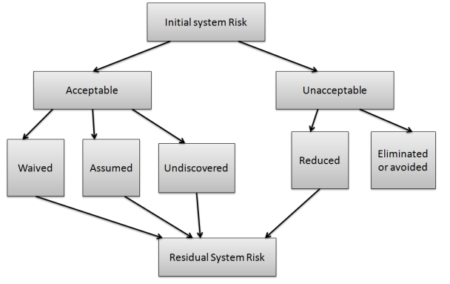

Risk Planning

**Consequently,** we will provide problems that faced previous projects and potential risks:

* The accuracy of the summary and mind map produce by the app may be low in accuracy compared to the summary that humans produce for the same articles or reports
* Complex sentences that need to focus and understand the context of the whole sentence. The app may not define its meaning precisely or it may show undesirable results for these sentences.
* If we try to add more than one language that the model can deal with, we will face many difficulties, most notably languages that contain many words and there is a difficulty in understanding their grammatical rules, and among these languages of course is the Arabic language, and accordingly we think that we will focus on the English language.

.

## 3.2-Consraints

To minimize constraints, then, it is first helpful to understand their definition. A constraint is anything that slows a system down or prevents it from achieving its goal. We could think of a constraint as a bottleneck in our processes that impedes our progress.

There are numerous, numerous distinctive sorts of constraint. Be that as it may, it’s vital to note that a framework cannot have hundreds or thousands of limitations at one time. The most extreme is capped. This can be since constraints are the variables that most restrain your production.

* people constraints are caused by not having enough skill for a project or having skills not related to our project but we distribute tasks that suitable to each one as we can . While this can be the case, in software development, having as well numerous talented individuals on a venture can moreover cause a people constraint (Known as and explained by Brooks’ law.)
* The idea of the project should be purposeful and its implementation solves an existing problem or facilitates doing work that would have required much effort and time to complete it . And we believe that our project meets these conditions. **otherwise** You're spending time creating things that consumers don't want or need.
* Equipment constraints are those delays caused by defective, moderate, or out of date gear or a need of adequate space. In our project it might be a lack of devices And in this case we may go to the web because it does not require devices with high capabilities, all we need are devices that can run the browser, and unlike that in Android, which requires devices with specific capabilities to run Android Studio

# 4- Project plan

Project planning is at the heart of the project life cycle, and tells everyone involved where we are going and how we are going to get there.

***Generate word cloud, summary & mind map automatically from articles using Natural language processing(NLP)*** is idea for our project and this is what we want to go to achieve **But How?**

the project work plan can be shown using Gantt chart to illustrate phases and tasks:

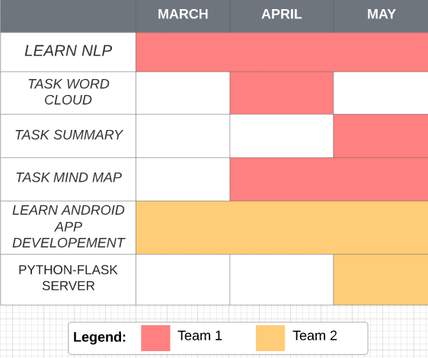

Gantt Chart

# 5- Software Quality Assurance (SQA)

(SQA) is easily a way to ensure quality in the software. It is the group of activities which ensure processes, procedures as well as standards suitable for the project and implemented accurately.

|  |  |
| --- | --- |
| **list of SQA activities** | **Description for each activity** |
| Executing Formal Technical Reviews: | An FTR is done to evaluate the quality and design of the prototype.   * In this process, a meeting is conducted with the team to discuss concerning the genuine quality prerequisites of the software and the design quality of the prototype. * This activity helps in discovering errors in the early stage of SDLC and reduces rework effort in the later stages. |
| Controlling Change: | In this activity, we use a combination of manual procedures and automated tools to have a mechanism for change control.   * By validating the change requests evaluating the nature of change and controlling the change effect, * it is confirmed that the software quality is maintained during the development and maintenance stages. |
| Enforcing Process Adherence: | This activity require for handle adherence amid the software development process. The advancement prepare ought to moreover adhere to the characterized methods.  This activity is a mix of two sub-activities which are explained below in detail:   * Product Evaluation:   This activity confirms that the software product is meeting the requirements that were discovered in the project management plan. It ensures that the set standards for the project are followed correctly.   * Process Monitoring:   This activity verifies if the correct steps were taken during software development. This is done by matching the actually taken steps against the documented steps. |

Table1: QSA

# Limitation of the System

We could not implement the Abstractive summary. The model is a bit large and needs to be trained on large data in order to produce perfect results. There are also some defects in the model, for example

Most current state-of-the-art techniques revolves around encoder-decoder models, that may not be scalable enough for long document summarization.

From our experience working directly in abstractive summarization

The results are often small and almost give a line or several lines of summary, but this summary is strong and highly efficient, as we tried the model on our Abstract and the result was pretty good

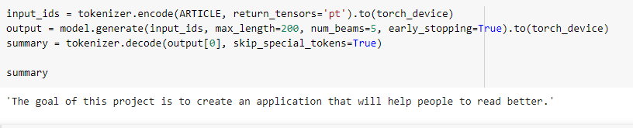

# We encountered problems including the lack of content related to this type of summary and in the end we failed to integrate the model with the application

# Conclusion and Future Work

When we talk about future work, we can talk about a way to integrate this type of Abstractive summary into our application, which will undoubtedly be a big plus especially if we could find a way to make the summary a little bit longer.

We have discussed in this document more than one service that can help people to read and extract important information from texts because we believe in the importance of reading and it is the first inspiring activity for all creative people who changed the course of history, and this is precisely a point that we referred to in the Abstract.

It is clear that we have focused on the mind map because of its advantages, and if it is extracted automatically from the texts, it will be an easy way to understand the content and there is consensus on its importance and the ease of remembering the mind map.

We face many difficulties, including, for example, the production of two versions of the application, one in Arabic and the other in English, and the lack of educational content for natural language processing (NLP)compared to other common topics.

All these challenges motivate us more for success and for the benefit to prevail and for the largest number of people to benefit from the application, and life is full of success and failure.

We hope that our application will help a lot of people, impress readers, and make reading a fun activity.

with our cooperation, we will be able to achieve the achievement.

# Reference

* Word Clouds & the Value of Simple Visualizations

<https://boostlabs.com/blog/what-are-word-clouds-value-simple-visualizations/>

* Automatic summarization

<https://en.wikipedia.org/wiki/Automatic_summarization>

# Automatic Text Summarization

<https://scialert.net/fulltext/?doi=itj.2009.1249.1255>

# Text Summarization with Python

<https://medium.com/@umerfarooq_26378/text-summarization-in-python-76c0a41f0dc4>

* How to Perform Abstractive Summarization with PEGASUS

<https://towardsdatascience.com/how-to-perform-abstractive-summarization-with-pegasus-3dd74e48bafb>

* (M. Abdeen, R. El-Sahan, A. Ismaeil, S. El-Harouny, M. Shalaby)

The Faculty of Computers and Information Sciences | Ain-Shams University Cairo, Egypt.

<https://www.researchgate.net/publication/224129737_Direct_automatic_generation_of_mind_maps_from_text_with_M2Gen>

* Generating mind map from an article using machine learning: Nurrokhim in 2019

<https://iopscience.iop.org/article/10.1088/1742-6596/1280/3/032023>